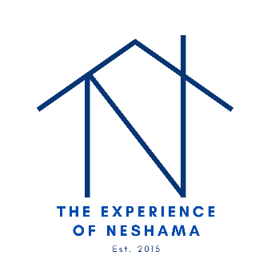

The Experience of Neshama Non-Discrimination Policy

• The Experience of Neshama does not discriminate on the basis of race, color, gender identity or expression, national origin, ethnicity, sex, age, or disability

• The Experience of Neshama provides reasonable accommodations for people with disabilities in a timely manner and free of charge, when they are needed to perform services. Appropriate accommodations include assistive devices and services, interpreters, and information in alternate formats

• The Experience of Neshama provides timely language assistance services for people with limited English proficiency (LEP) free of charge, when they are needed to perform services. Language assistance services include translated documents and oral language interpretation

• Ask the staff person you are working with how to obtain accommodations or language assistance services to meet your needs

• Please contact the President Ryan Eckdahl (ryan@exnesh.com) if you wish to file a complaint about any of the items covered in the nondiscrimination notice

If you wish to file a complaint with the Office for Civil Rights (OCR), in Minnesota, contact the Minnesota Department of Human Rights at 651-539-1100 or 1-800-657-3704 or https://mn.gov/mdhr/about/contact/

